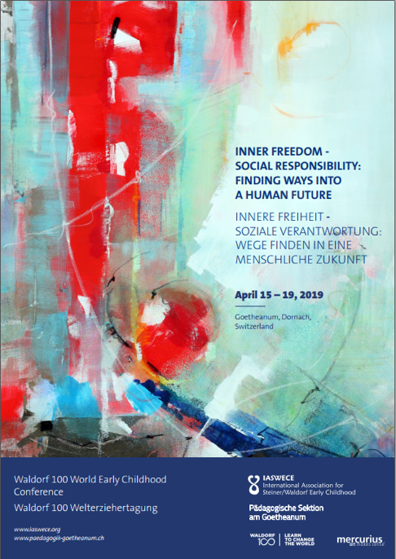

Practical Information

Registration opens on October 4th: https://www.goetheanum.org/en/conferences/waldorf-100-world-early-childhood-conference/ or http://www.iaswece.org/home/
Conference fee (including lunch and dinner): Regular fee: CHF 460. Solidarity price: 550 CHF Application for a reduction is possible until November a9 at the latest through the online registration form. We would be very pleased if you or your institution could pay the solidarity price - the more participants pay the solidarity price, the more reduced tickets and travel cost support we can award.
Application for travel support: Apply on the online registration form. Please apply by November 19 at the latest. We will let you know by December 10th how much travel support we can offer you.
Accommodation: Dormitory-style accommodation in classrooms can be booked with your registration. Price: 80 CHF. If you are looking for other accommodation, please contact: https://www.goetheanum.org/en/visiting/visitor-information/
Languages: The lectures will be held in German or English and translated simultaneously into the following languages: English/German, Chinese, French, Italian, Russian, Spanish. If required, also in Hungarian and Japanese. Please indicate when registering for which language you need a translation.
Languages in the working groups: The lists of working groups I and II indicate the languages the working group leaders speak and the languages into which the respective working groups will be translated. In addition, you can organize a whispered translation into another language yourself with your acquaintances.
Discussion groups (from 11 -12:30): The organizers will put you in a group in which a language is spoken that you understand. On arrival, you will be told which group you will be working in. (See information sheet: "Your cooperation is needed")

